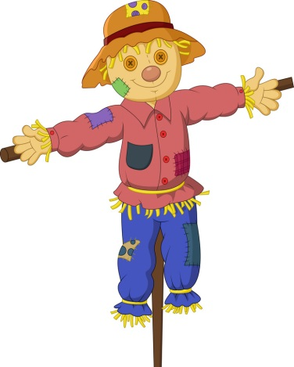
Cheapside Scarecrow festival 2020 Registration form

Thank you for entering Cheapside Village Scarecrow festival 2020.
The idea is to make your own ‘scarecrow’ and display it outside your home on Saturday July 11th & Sunday 12th July. The theme this year is ‘A night at the movies’ and you will need to select a film, actor or character to dress your scarecrow up as.
The festival weekend will start at 10.30am on Saturday July 11th. On the weekend there will be a map and clues available at the village hall for all participants to get hunting and identify as many Scarecrows in the village as they can!
You do not need to make a scarecrow to participate in the event but it would be great to get as many around our village as possible!
There are lots of tips on Youtube and the internet for how to make your scarecrow but you may have your own ideas and anything goes.
Please complete the below information and either email to enquiry@cheapsidevillagehall.co.uk or post in the black letter box outside the village hall by Friday 3rd July.

Name:

Address:

Contact number and email:

Chosen film / actor for Scarecrow:

